# ****Phase 7: Integration & External Access****

**Prepared by:** Kakumani Naga Jahnavi

## ****Overview****

Phase 7 focuses on integrating external systems and enhancing accessibility in the Smart Healthcare CRM. This phase ensures that patients, doctors, and hospital staff can efficiently interact with the system while leveraging external services. Key integrations include location-based services, real-time notifications, patient portals, and secure authentication mechanisms.

## ****Google Maps API Integration****

The system integrates the Google Maps API to locate nearby hospitals and laboratories. This allows patients and healthcare providers to quickly find medical facilities within a specified radius. By using the Maps and Places APIs, the system retrieves real-time geographic data and presents it through the user interface. This feature improves patient convenience and enhances decision-making for urgent medical needs.

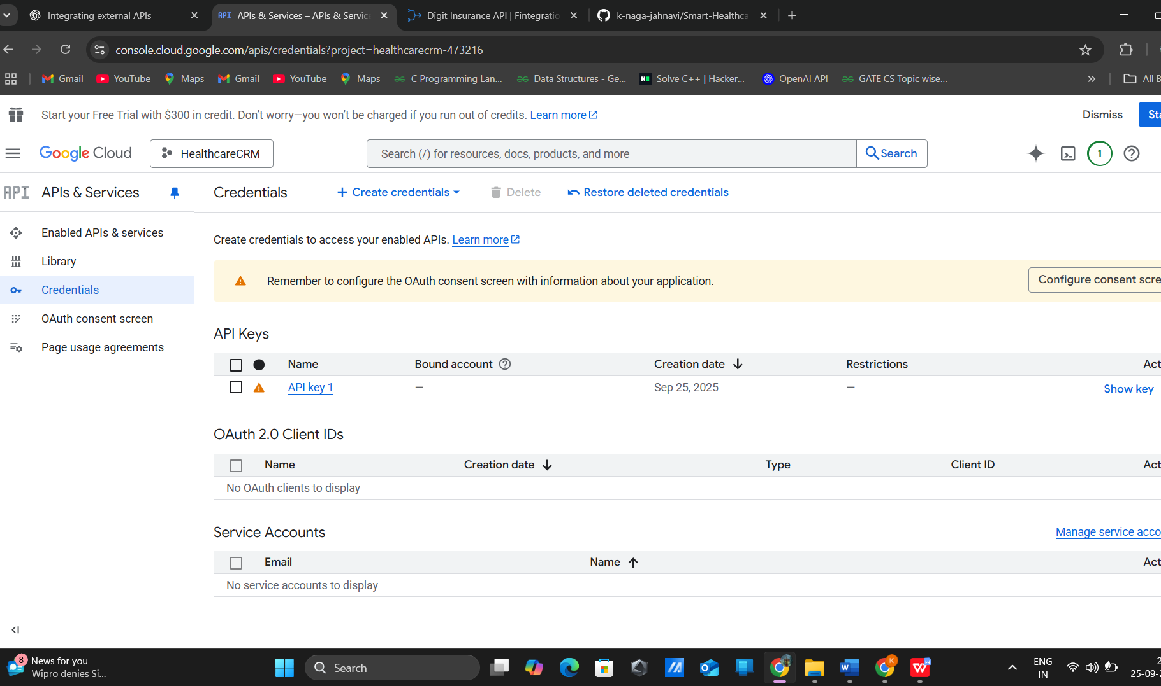

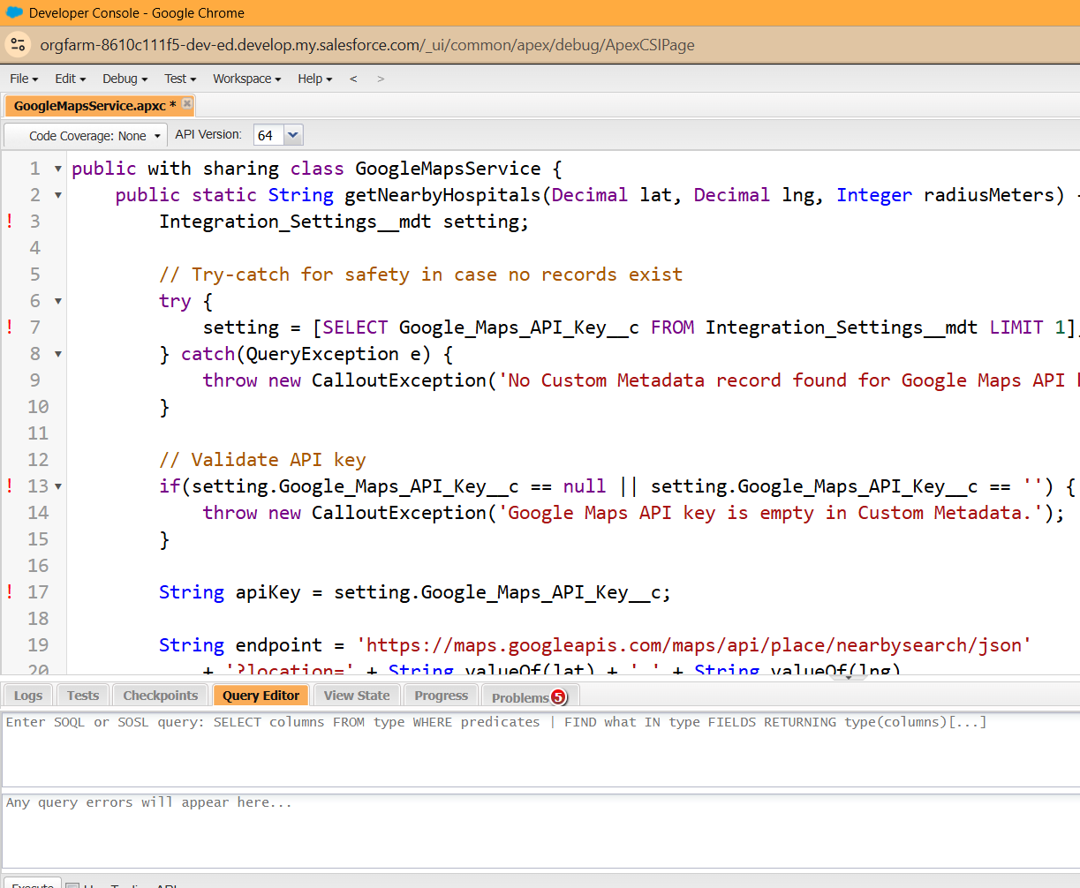

## ****Insurance API Integration****

Although planned initially to fetch claim details and status from insurance providers, this step is optional and can be implemented in future updates. Integrating insurance APIs would allow automatic retrieval of claim information, reducing manual verification and streamlining patient insurance processes.

## ****Platform Events for Urgent Cases****

Platform Events are utilized to notify doctors immediately about urgent or critical cases. When a patient’s appointment is marked as critical, a platform event is published to the system. Subscribed doctors receive instant notifications, enabling prompt medical intervention. This real-time alert mechanism enhances patient safety and operational efficiency within the hospital workflow.

## ****Experience Cloud: Patient Portal****

A dedicated patient portal is created using Salesforce Experience Cloud. The portal allows patients to view their appointment history, book new appointments, and interact with the hospital system securely. This feature empowers patients with direct access to their medical data and streamlines communication with healthcare providers. Experience Cloud ensures a responsive, user-friendly interface that aligns with modern patient expectations.

## ****OAuth for Secure Logins****

Secure authentication is implemented using OAuth protocols to manage logins for both patients and doctors. This ensures that sensitive patient information is accessed only by authorized users. By integrating OAuth, the system provides a robust security layer, allowing safe login through external identity providers while maintaining compliance with privacy regulations.